Assignment Submission Report

Name: Charles Taggart
Course: FSDI-109
Cohort: 65
Assignment: Assignment 2 React store - Admin
GitHub Repository Link: https://github.com/chucktagg83/project107.git

Evidence of Functionality
Frontend/UI
Attach 3 screenshots only:
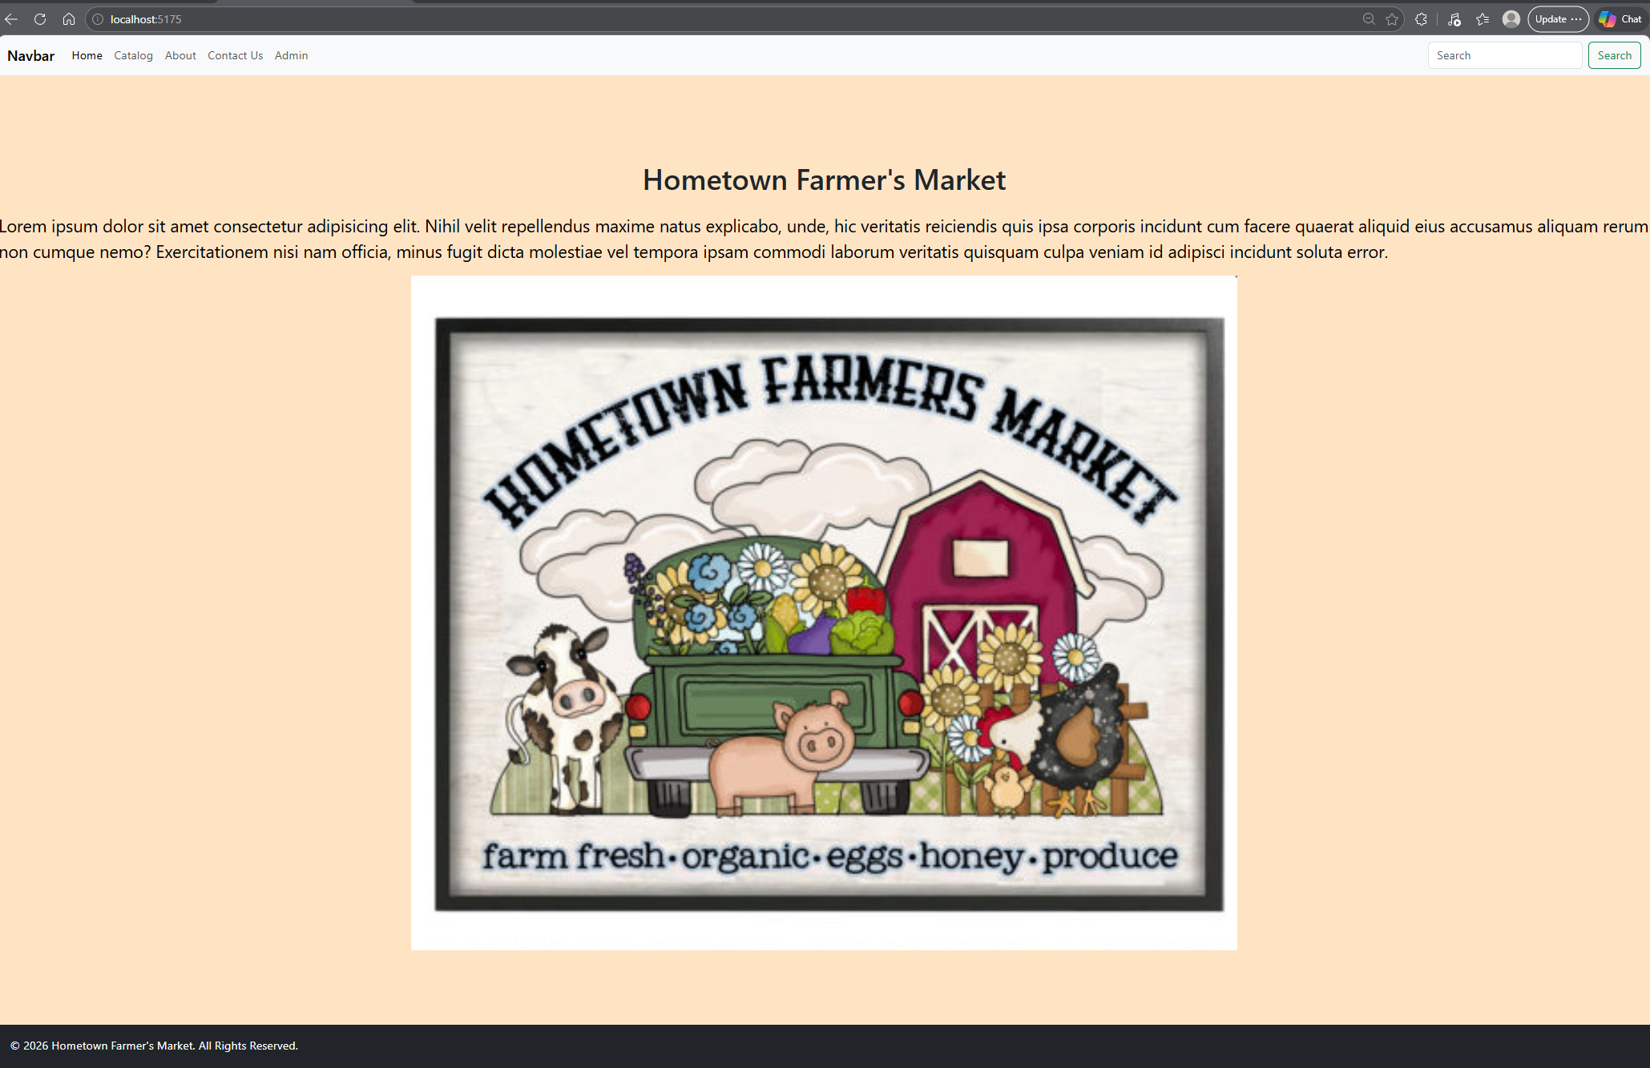
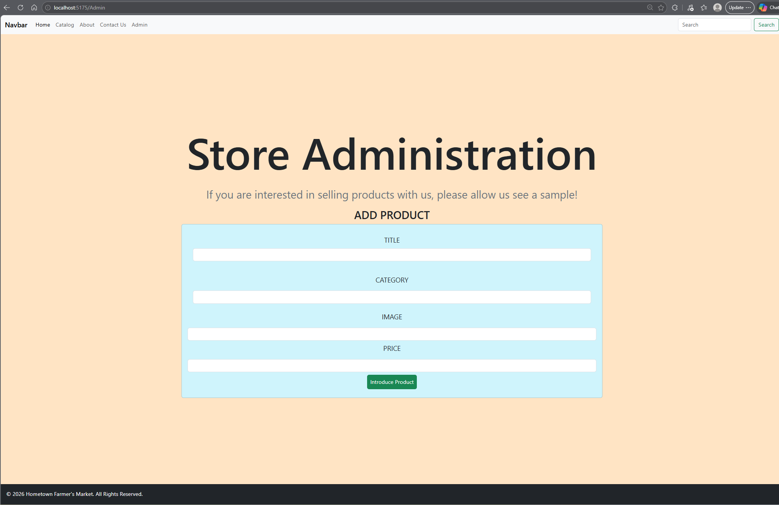
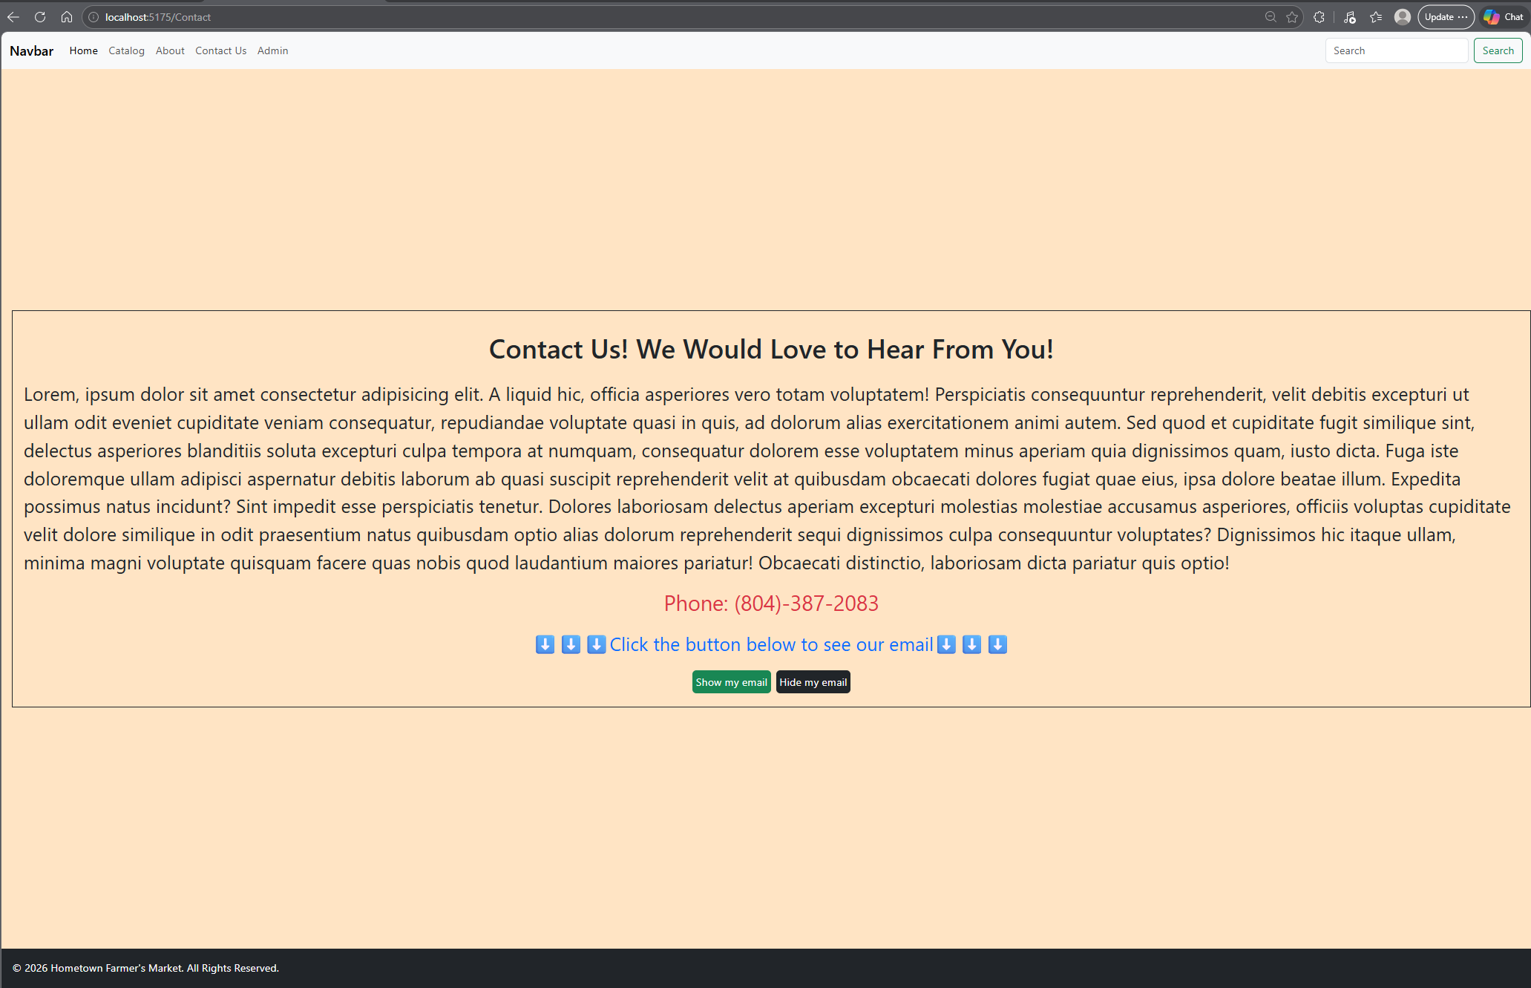

AI Disclosure (Required) - Highlight the one that applies
- I did not use AI
- I used AI for help
- AI generated parts of my code

